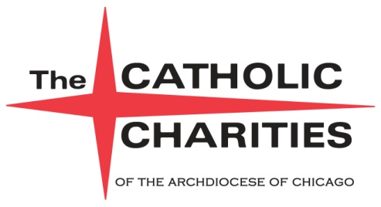

|  |  |
| --- | --- |
| **FOR IMMEDIATE RELEASE**  **NOVEMBER 20, 2013** | **Contact:** Kristine Kappel  **Phone:** 312-655-7019  **E-mail:** kkappel@catholiccharities.net |

**Zipcar and Chicago Loop Alliance Partner to Create “Art Cars” to Drive Support for Catholic Charities After Supper Visions Program**

*“Fueling Local Art” campaign raises money, awareness for the homeless living in Chicago*

**Chicago, IL** – Local Chicago artists Czr Prz and George Berlin took a blank canvas – a car! – and turned them into works of art through the global car sharing company Zipcar and not-for-profit Chicago Loop Alliance. Now through December 22,Catholic Charities After Supper Visions Program will be granted $1for every hour the “art cars” are driven by customers. All proceeds go directly to the Catholic Charities After Supper Visions Photography Program, which encourages participates who are homeless or at risk of homelessness to express creativity and individuality through their work.

Zipcar, Inc. and Chicago Loop Alliance launched their “Fueling Local Art” campaign last summer to create pop-up art out of Zipcars. The cars have been featured at various festivals and events throughout the city to promote the power of art. Drivers can reserve a Zipcar “art car” at zipcar.com/chitownart.

The decade-old After Supper Visions photography program has grown to feature the work of dozens of artists every year and builds a support system for the homeless or people at risk of homelessness. Tuesday Night Supper guests are given a disposable camera and offered a photography class through Catholic Charities. They are then encouraged to take photographs of the city from their point of view.

Prints sold through the After Supper Visions program directly support the artists and provide them with funds to help them rent apartments, pay utility bills, purchase food and clothing or continue pursuing their photography interest.

“Over the past ten years, some artists have earned enough from the sale of their artwork to make security deposits on apartments, pay tuition at community colleges, buy a new camera or computer, and become employed as photographers,” said Monsignor Michael M. Boland, President of Catholic Charities of the Archdiocese of Chicago.

-more-

***Page 2 – Zipcar Art Cars to Benefit After Supper Visions***

Each Tuesday evening, Catholic Charities and volunteers provide a warm, friendly environment and sit-down dinner which feeds more than 150 homeless people.

For more information about Catholic Charities’ After Supper Visions Program and other Catholic Charities programs that help the homeless visit [aftersuppervisions.com](http://aftersuppervisions.com) or catholiccharities.net.

**About Catholic Charities**

Helping people in need for more than 96 years, Catholic Charities of the Archdiocese of Chicago is one of the largest private, not-for-profit social service agencies in the Midwest, annually assisting more than one million persons in Cook and Lake counties without regard to religious, ethnic or economic background. Catholic Charities fulfills the Church’s role in the mission of charity by providing compassionate, competent, professional services that strengthen and support individuals, families and communities.

###