[](http://www.wilmettebeacon.com/)

**Wilmette photographer works with homeless**

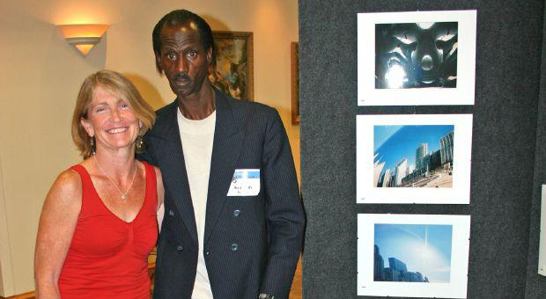

Jody O’Connor, of Wilmette, a professional photographer and founder of Catholic Charities After Supper Vision, is shown with one of the homeless clients she worked with through the organization’s photography program. Photo Submitted

Staff Report

June 4, 2015

Jody O’Connor, of Wilmette, is a professional photographer and founder of Catholic Charities After Supper Vision program. The program enables homeless clients from the Catholic Charities Tuesday Night Suppers to photograph Chicago through their perspective.

She works with the homeless clients and teaches them photography skills every Tuesday night. Not only has O’Connor helped lead the program for 13 years, but she has dedicated her time by volunteering at Catholic Charities and has helped hundreds of Chicago’s homeless by giving them a creative outlet and showing them their value.

The artists involved in the Catholic Charities After Supper Visions program have found photography as a means of expressing themselves. These artists are guests from the Catholic Charities Tuesday Night Suppers, and they have been given the opportunity to capture pictures that strike them as beautiful or interesting. Many of them are homeless or at risk of homelessness. Some have never picked up a camera before, but the photographs provide moments from a different point of view – theirs.

 The public is invited to a free reception to view these beautiful photos of Chicago taken from the perspective of homeless. The 13th annual After Supper Visions photography exhibit is from 5-7 p.m. Friday, June 12 and from 1-3 p.m. Saturday, June 13 at 721 N. LaSalle St., Chicago. The family-friendly event features photographs from 62 artists. The prints and notecards on display are available for purchase at the exhibit. Many of the artists use the profits to help with security deposits for apartments, paying utility bills, buying food or purchasing digital cameras to encourage their new passion.

“It’s special to be a part of this beautiful event,” said Beate H., an artist and participant in the After Supper Visions program. “There is never the perfect photograph taken, but when a person stops and looks at my photographs and doesn’t only walk by, that’s a perfect moment and a perfect photograph, because I touched his or her mind.”

The After Supper Visions program was founded 13 years ago by staff at Catholic Charities and volunteers who served dinner to the guests at the Tuesday evening supper program. Supper guests are given a disposable camera and encouraged to photograph the city.

“The After Supper Visions program has given more than 200 artists an opportunity to express themselves through photography,” said Monsignor Michael M. Boland, President of Catholic Charities of the Archdiocese of Chicago. “To date more than 23,000 photos have been taken, and $110,000 has been raised to help our guests become more self-sufficient.”

To learn more about the artists or to purchase prints and notecards, visit aftersuppervisions.com.